**The World Trophy of Professional Tiramisù FIPGC**

OFFICIAL RULES

Host Fiera Milano 13 October 2023

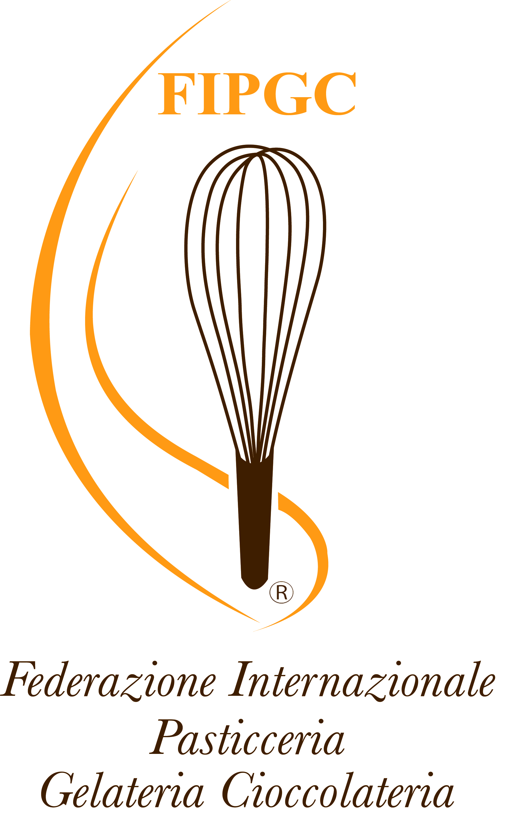

* ***To Whom it Applies***
* The participation to the Professional Tiramisù, organized by the International Federation of Pastry, Ice Cream and Chocolate , is open to all the countries of the world.
* The World Trophy of Professional Tiramisù is divided in 2 categories. Each competitor has to partecipate and present both categories: CLASSIC TIRAMISU’ AND INNOVATIVE TIRAMISU’.
* The FIPGC Tiramisu World Championship is restricted for chefs, pastry chefs and gelato makers.
* The Championship is held every two years, in 2023 it will take place at Host Fiera Milano in Rho on 13 October 2023.
* ***To access the competition:***
* The competitors must send the application form (annex to the official rules) send by email: info@internationalfederationpastry.com or [segreteria@federazionepasticceri.it](mailto:segreteria@federazionepasticceri.it)
* Each competitor must complete the application form indicating the competitors nation and data, accepting the terms and conditions of the official rules, then complete it by paying the sum of € 150,00 latest by the
* 31st January 2023, by bank transfer to:
* BANKING COORDINATES: BANCA DI CREDITO POPOLARE – FILIALE DI TORRE DEL GRECO (NA) Federazione Internazionale Pasticceria Gelateria Cioccolateria, ASSOCIATION WITHOUT PURPOSE OF PROFIT : Terza Traversa Privata Luigi Sapio, 14 D – Portici – 80055 (NA) ITALY

IBAN: IT76U0514240302CC1026039478 –

Swift: BCP TIT NN XXX

Reason for transfer: Name of country (example: Italy) Registration for Tiramisu World Trophy.

* ***The Partecipants and the Jury:***

The Jury of the World Championship will be made up of international judges and the President of the Jury, all having proven experience in Pastry and in international competitions. The President of the Jury and the

judges will evaluate individually each team without measuring with each other, if necessary they can refer to the President of the Jury. The President of the Jury could ask support to the Supervisor for the

aspects and details of the official rules, to certify the choice of the measures and decisions to be taken on the evaluations and penalties for anything not mentioned in the FIPGC Official Rules.

* The competitors could, just in case of real necessity, communicate with the President of the Jury, the Commissioners of the competition and the judges.
* All participants must comply to the official rules. All correspondence must go through the Managers of the organization, the competitors are not allowed to contact the Judges or the President of the Jury.
* For unsuitable behaviors regarding the rules and the competition, the Judges and the President of the Jury may apply penalties or even the exclusion of the team. Competitors will not have any help from outside, penalty the exclusion or penalization from the competition.
* The Judges’s judgment is unquestionable.
* ***Clothing:***
* The Organization will provide each participant 1 official jacket (to use during the competition and the award ceremony) 1 apron.
* All competitors must wear the official clothing consisting in the competition’s official jacket, black trousers, and black shoes.
* It is absolutely forbidden to use clothing that does not comply with the indications above or to affix other logos to the clothing.
* Furthermore, throughout the competition, it is absolutely forbidden to display logos or other advertising material on the equipment or raw materials, the same must necessarily have all promotional labels obscured, except those of the official sponsors of the competition.
* From the moment of admission to the competition the competitors hand over to the organization the right to use photos, videos, audios, recipe book and all other entries for propaganda purposes and everything connected to it in all its forms of use, renouncing from that moment any request for compensation of damage, reimbursement of expenses and various payments in general.
* ***Recipe book of the Competition***
* Each competitor must deliver n. 8 presentation brochures complete with technical data sheet, recipe book, procedure and indication of any allergens, brief personal biography, photo of the competitor, a brief history of tiramisu in their own country indicating how and when it was introduced and how it developed. Each competitor will produce the exhibition brochure to his liking (it must be written in English and in the mother tongue of the participant).
* All the requested materials will have to be delivered in paper and in digital form (preferably in pdf format on a CD or a USB pendrive) to the President of the Jury at the beginning of the competition; in case of non-delivery or partial delivery, a penalty of 1-5 scores will be applied on the final score obtained by the competing Team of the general amount of scores.
* The photos used for the brochure of every desert should be 95% (minimum) similar to the edible one.
* Recipe book, photos, biographies and presentation brochures of the participating teams, will be owned by the Organization, with freedom of publish in each advertising channel at it disposal.
* If the competitor wants to bring photographers, local or national television staff, has the duty to inform in advance the organization.
* **Ingredients and accepted procedures**

The organization will provide to the competitors a blast chiller, tables, positive and negative refrigerator, professional stand mixer, microwave, induction hob, chocolate tempering machines, batch freezer. The organization will communicate to all the participants, in detail, the equipment and raw materials present inside the workstation area. Small equipments (example: boule, scales, knives, sugar lamp, spatulas, ladles, molds etc.) shall be brought by the participants. The organization will make available neutral tables with the same tablecloth for all competitors in order to arrange the works. The lighting and/or spotlights to illuminate the artistic works will be brought by the competitors.

➢ Competitors can bring any machinery they need during the competition into their box, prior permission from the organization.

➢ The International Organizing Committee reserves the right to make changes to the regulation, promptly communicating it to the participating Teams by email.

The following recipes are ADMITTED in both the competition programs:

* Baked bases (Savoiardi, buisquit, sponges)
* Chocolate decorations, Marzipan, sugar and crisps.

Every competitor has to bring an empty cup or the container that he is going to use in the Classic and Innovative Tiramisù competition to allow the Jury to make the necessary checks (gross weight and net weight).

* As far as concerned for food products brought from abroad by the competitors, these will be checked by a FIPGC manager, who will ensure the expiry date, the origin and the use of products not allowed in the host country of the event, as it is necessary the traceability of all the finished products introduced into the workstations.

The Championship will be on 13th October 2023 with the following program:

**FIRST ROUND OF COMPETITORS**

8:00: competitors entry to the workstations

8:30 start of the competitions

10:30 am: Innovative Tiramisu Tasting

11:30 am: Traditional Tiramisu Tasting

12.00 am: the competitors must leave the working area after having cleaned up.

**SECOND ROUND OF COMPETITORS**

12:30 competitors entry to the workstations

13:00: Start of the competition

3.00 pm: Innovative Tiramisu Tasting

4 pm: Traditional Tiramisu Tasting

4.30 pm: competitors must leave the workstations after having cleaned up.

PRIZE GIVING WILL BE HELD AT 5 PM ON THE 15TH OCTOBER BEFOR THE PRIZE GIVING OF THE PASTRY WORLD TROPHY.

**The order of presentation to the jury will be made before the competition starts, according to the workstation assigned.**

* **Program**
* The World Trophy of Professional Tiramisù is divided in 2 categories. Each competitor has to partecipate and present both categories: CLASSIC TIRAMISU’ AND INNOVATIVE TIRAMISU’.

**Classic Tiramisù**

* Competitors will have to make 1 (one) traditional tiramisu diameter 20 cm (or square 20x20 side) which will be portioned by the competitor to let the judges taste it and 1 display single portion presented on a plate or glass that represents the prepared tiramisu and must be displayed on the presentation table .
* In this preparation the tiramisù could contain only the following ingredients: mascarpone cheese, eggs, sugar, savoiardi, cocoa, coffee.
* Any participant who adds ingredients not included in the above list, (ex. Alcohol or else) could be excluded from the competition.

**Innovative Tiramisù**

* Competitors can present a single portion or a cup or a plate dessert.
* Competitors are free to use the mold they deem most suitable for their creation if they choose to present a single portion, in the same way they can choose a cup (brought by the competitor) as they see fit, however, if they decide to present a dessert on the plate, the organization willsupply the dishes to the contestants for dessert.
* The competitors have to make 6 tiramisù cups (single portion) + 1 to exhibit
* For any shape chosen, the weight of each single portion presented must range between 90 and 110 g.
* It has to have at least a baked base and at least one kind of cream.
* **SCORES**
* For every category (traditional tiramisù, innovative tiramisù), there would be different criteria of evaluation. The above percentage show us, on a scale from 1 to 100, how important each component will have to reach the final score.
* The evaluation of the 5 (five) judges will be unquestionable and unchallengeable.

**Classic Tiramisù:**

70% Taste

30% Execution  
 **Innovative Tiramisù:**

50% Taste

20% Asthetics

20% Execution

10% Innovation

**Penalties:**

Not compliant weight to the rules: **penalty of 1 point for every 5 g of excess or defect to be subtracted from the overall final score of each single judge.**

Delay on the dessert presentation: **penalty of 1 point for each minute of delay, to be subtracted from the overall final mark of each single judge.**

* The dessert will be considered ready when it will be positioned on the exposition table in front of the workstation.
* ***Awards***

**1° Team classified:**

* World Cup of Professional tiramisù FIPGC
* Gold Medal for the World Champions FIPGC
* Certificate of honor

**2° Team classified:**

* Silver Medal
* Certificate of honor

**3° Team placed:**

* Bronze Medal
* Certificate of honor
* **Special Awards**
* Best Classic Tiramisù
* Best Innovative Tiramisù

**For the other positions:**Certificate of Participation for all the participating teams.

* ***Where and when***
* The Professional Tiramisù World Championship will take place at the HOST Fiera Milano Fair, Strada Statale 33 del Sempione, Rho Milano (MI) on 13TH October 2023. [www.host.fieramilano.it](http://www.host.fieramilano.it)
* ***The accommodation***
* The Organization will take charge of the accommodation for the Teams for two nights, on the following days: 12-13 October 2023. On 14 October 2021, all the competitors must leave their accommodation by 10:00 am. All expenses will be paid by the participants if they stay longer than the date and time established. On the days of the competition, the organization will provide the participating teams with a shuttle bus for travel from the hotel to the fair and vice versa.
* ***Final arrangements***

All teams who have sent their application by 30st January 2023 accept all the terms and conditions referred to in the present regulations from the date indicated. The organization will be exempt from every responsibility for any dispute with the score, which will be the indisputable judgement of the Official Jury, and the President of the Jury, all notifications must be presented to the President of the Jury at the end of every trial of the competition in writing. The organization reserves the possibility to cancel the competition for reasons beyond his control (in this case, the amount paid for the participation will be refunded to the competitors) and also to make changes to the regulations for logistical issues that do not depend on the said organization. The parties hereto undertake on the 30st January 2023 from the moment the letter of confirmation of acceptance to participate in the competition as per these regulations to sign an original copy of this deed. In the absence of the said deed, the competitors can be excluded from the competition at the discretion of the Organizers with there being no responsibility on the part of the latter, renouncing from that moment onward any request for compensation and reimbursement.

The Team expressly authorizes the organization, as well as the people delegated by them, for the official enrollment within the International Federation of Pastry Ice Cream and Chocolate and also authorizes the treatment of the limited personal data at the predisposition of the competition and its present and future publication for which they have expressly accepted to participate in accordance with Legislative decree 196/2003. All participants will have free access into the fair, which will be consigned on 20 October in the hotel where the teams are staying; tickets for any companions, supporters and relatives must be requested to the Organizational Committee before 1 October 2021. The Organizational Committee will send the entrance codes to get free tickets on the Fiera Milano e-mail. People requesting them must then print their own fair access. Any inconsistent behavior will not be accepted after the judgment has been discussed and accepted by the jury (by any social, as established by art. 595, paragraph 3, c.c. of the Italian Law, television, newspaper and any other means of communication).

TICK FOR ACCEPTANCE O ACCEPT O NOT ACCEPT

From the moment of admission to the competition the competitors cede to the organization the right to use photos, videos, audios, recipe book and all other entries for propaganda purposes and everything connected to it in all its forms of use, renouncing from that moment any request for compensation of damage, reimbursement of expenses and various payments in general.

TICK FOR ACCEPTANCE O ACCEPT O NOT ACCEPT

**APPLICATION FORM THE WORLD CHAMPIONSHIP OF PROFESSIONAL TIRAMISU’ FIPGC 2021**

|  |  |  |  |  |  |  |  |  |  |
| --- | --- | --- | --- | --- | --- | --- | --- | --- | --- |
| **PARTECIPATING COUNTRY : -------------------------------------------------------------------** | | | | |  | | |  | |
| COMPETITOR: SURNAME: NAME: | | | | | | |  | |  |
| born in |  | | |  | | on | | | |
|  | (town – specify State) | | | ( prov.) | | (day/month/year) | | | |
| resident at |  | | | | |  | | | |
|  | (town of residence) | | | | | (prov.) | | | |
|  | | | | | | n° | | | |
| (way, square.) | | | | | | (num. civico) | | | |
| Post Code Telephone | | | | | | | | | |
| telephone | | fax: | cellulare: | | | | | | |

(with international code) (with international code)

|  |  |
| --- | --- |
| sito internet: | e-mail: |

**Would like to apply for the World Championship of Professional Tiramisù**

**FIPGC**

* *For this purpose declares:*

1. essere in possesso dei requisiti di adesione di carattere generale, nonché dei requisiti specifici per la tipologia di appartenenza, previsti dal Regolamento di cui sopra To be in possession of the general requirements of participation, also the specific requirements for the type of membership seen in the rules above;
2. To accept all the terms and conditions of the rules and application enclosed.
3. To communicate promptly eventual variations declared in the present application of membership;
4. To respect and not undertake activities contrary to the purpose of the Organization;
5. To be in possession of all he althand sanitary requirements for the handling of food.

**Legislative decree n. 196 dated 30/06/2003 and further amendments and additions“Personal data and protection Code”: Privacy policy**___________________________________________________________________________________________________________  
**Information**: In reference to Article 13 of the Legislative Decree 196 dated 30/06/2003, we inform you that the processing of data will be made (directly/or through societies, institutions or associations) for the purposes strictly connected to the requests above. All data will be processed lawfully and correctly, the data will be recorded and stored in computer files/or on paper (guides, brochures, promotional material for national and international circulation). As established in Article 7, you have the right, at any moment, to consult or request the modification (should you encounter errors and/or variations) the cancellation of the notified data. The eventual refusal to provide, all or in part, the data required, will automatically lead, even without any communication with regards to, the exclusion of the establishment or continuation of any further relationship. **Consensus**: I declare to have received the information referred to in Article 13 of Legislative Decree 196/03 and further amendments and additions, of which I am aware of the contents and express after careful evaluation and self-determination, consent to the processing of my personal data as described in the said article.  
 TICK FOR ACCEPTANCE O ACCEPT O NOT ACCEPT

**Signature of Participant___________________**

***Si ringrazia per la collaborazione****:*

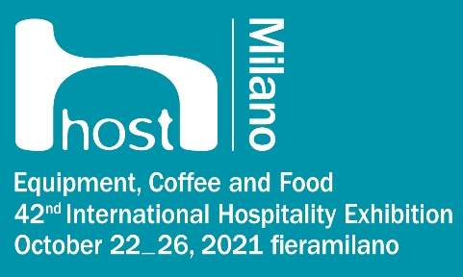

* [*www.federazionepasticceri.it*](http://www.federazionepasticceri.it)
* [*www.internationalfederationpastry.com*](http://www.internationalfederationpastry.com)
* [*www.campionatomondialepasticceria.it*](http://www.campionatomondialepasticceria.it)
* [*www.pastryworldchampionship.com*](http://www.pastryworldchampionship.com)
* [*www.campionatomondialecakedesigner.it*](http://www.campionatomondialecakedesigner.it/)
* [*www.cakedesignersworldchampionship.com*](http://www.cakedesignersworldchampionship.com/)
* [*www.campionatoitalianocakedesigner.it*](http://www.campionatoitalianocakedesigner.it/)
* [*www.federazioneitalianacakedesigner.it*](http://www.federazioneitalianacakedesigner.it)
* [*www.host.fieramilano.it*](http://www.host.fieramilano.it)